Caribbean Advanced Proficiency Examination

Applied Mathematics

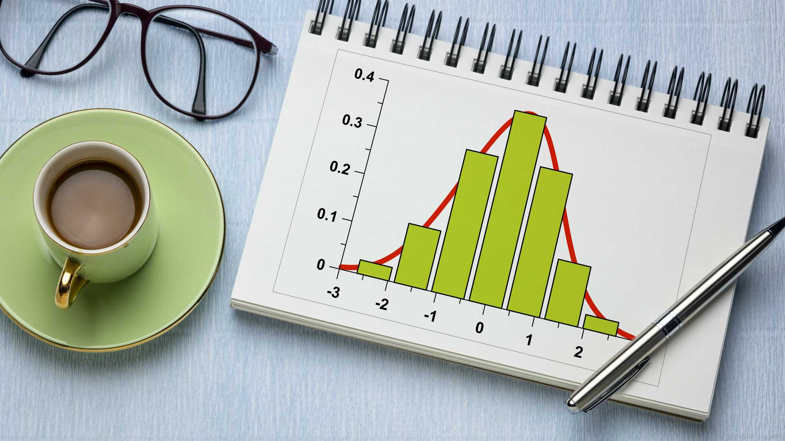

**Centre:** Mona High School

**Centre Number:** 100152

**Name of Candidates:** **Candidate Numbers:**

Syee Dassado 1001520219

Chevannese Ellis 1001520286

Romero Brown 1001520103

**Teacher:** Ms. McLoud

**Territory:** Jamaica

**Year:** 2021-2022

*Table of Contents*

Title 3

Problem Statement 4

Purpose of Project 5

Methodology 6

Presentation of data 7

Analysis of Data 11

Discussion 13

Conclusion 14

Bibliography 15

Appendix 16

# Title

The relationship between the Mid-Term and End of Term results

# Problem Statement

An assessment into the relationship between the Mid-term and End of Term Communication Studies' results of sixth form students during the period of 2021 to 2022 at Mona High School regarding their eligibility for CAPE.

# Purpose of Project

The Caribbean Advanced Proficiency Examination (CAPE) is an assessment that is generally taken by both lower and upper sixth form students, for either tertiary education or a prerequisite entrance for colleges. CAPE and CSEC (Caribbean Secondary Education Certificate) share some similarities since both of them are two-year programs. A major distinctive factor that separates these two examinations is the compulsory subject. The mandatory subject for CSEC is English A and Mathematics, whereas CAPE only has one mandatory subject which is Communication Studies. Both Mid-term and End-of-term results can be incorporated to judge whether or not the sixth form students are meeting the objectives established by the syllabus in preparation for their external exams.

Hence, the researchers seek to ascertain if there is a relationship between the Midterm and End of Term results for lower sixth form students to anticipate their level of success in CAPE exams. In addition, this research will also be used for the comparisons between the current and historical records of students' results by institutions to determine if the overall grades are improving progress over time.

# Methodology

Even though Mona High School has a population of 2500 students, the sampling frame encompasses 103 students in form six, where the study lies. As a result, a sample of 30 students was chosen to carry out this investigation. An interview and observation were selected as appropriate data collection instruments by the researchers.

The primary data collection was an observation. The researchers were authorized by the sixth form coordinator to utilize the academic record of those who participate in both internal assessments for Communication Studies. A random sample of 30 students was chosen from two classes. Students of the records were then registered as numbers for anonymity along with their respective data depicted in a table for an effective analysis.

Lastly, the interview was another suitable instrument of data collection as the researchers were able to receive instantaneous responses as well as additional information to gain an insight into the concepts being investigated. Five students from the thirty students in the sampling group were selected for the interview.

# Presentation of data

Table 1: Representing the Communication Studies Mid Term Results vs Communication Studies End of Term Results

|  |  |  |
| --- | --- | --- |
| **Student** | **Communication Studies Mid Term Results** | **Communication Studies End of Term Results** |
| 1 | 50 | 53 |
| 2 | 52 | 86 |
| 3 | 52 | 64 |
| 4 | 55 | 84 |
| 5 | 40 | 56 |
| 6 | 32 | 60 |
| 7 | 55 | 69 |
| 8 | 58 | 78 |
| 9 | 50 | 57 |
| 10 | 65 | 74 |
| 11 | 62 | 74 |
| 12 | 35 | 50 |
| 13 | 56 | 60 |
| 14 | 46 | 50 |
| 15 | 50 | 68 |
| 16 | 43 | 50 |
| 17 | 47 | 35 |
| 18 | 65 | 63 |
| 19 | 56 | 35 |
| 20 | 62 | 80 |
| 21 | 68 | 53 |
| 22 | 38 | 40 |
| 23 | 80 | 83 |
| 24 | 65 | 70 |
| 25 | 63 | 66 |
| 26 | 53 | 60 |
| 27 | 45 | 40 |
| 28 | 50 | 57 |
| 29 | 82 | 70 |
| 30 | 48 | 60 |

**Figure 2:** Box and Whisker plot showing comparison of Mid Term and End of Term Exam Results in Communication Studies.

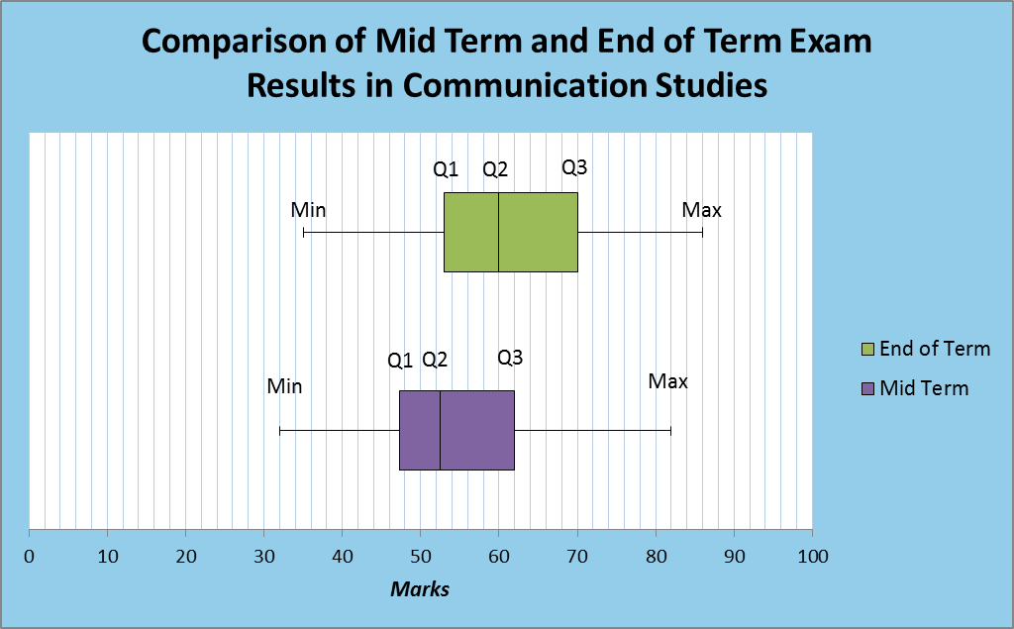

|  |
| --- |
| **KEY** |
| Q1 = Lower Quartile |
| Q2 = Median |
| Q3 = Upper Quartile |
| Min = Minimum |
| Max = Maximum |

**Figure 3**: Stem and Leaf plot showing Communication Studies Mid Term Results

|  |  |  |  |  |  |  |  |  |  |  |  |  |
| --- | --- | --- | --- | --- | --- | --- | --- | --- | --- | --- | --- | --- |
| Stem | Leaf | | | | | | | | | | | |
| 3 | 2 | 5 | 8 |  |  |  |  |  |  |  |  |  |
| 4 | 0 | 3 | 5 | 6 | 7 | 8 |  |  |  |  |  |  |
| 5 | 0 | 0 | 0 | 0 | 2 | 2 | 3 | 5 | 5 | 6 | 6 | 8 |
| 6 | 2 | 2 | 3 | 5 | 5 | 5 | 8 |  |  |  |  |  |
| 8 | 0 | 2 |  |  |  |  |  |  |  |  |  |  |

|  |
| --- |
| **KEY** |
| **5|5** Means 55 |

**Figure 4**: Stem and Leaf plot showing Communication Studies End of Term Results

|  |  |  |  |  |  |  |  |  |  |
| --- | --- | --- | --- | --- | --- | --- | --- | --- | --- |
| Stem | Leaf | | | | | | | | |
| 3 | 5 | 5 |  |  |  |  |  |  |  |
| 4 | 0 | 0 |  |  |  |  |  |  |  |
| 5 | 0 | 0 | 0 | 3 | 3 | 6 | 7 | 7 |  |
| 6 | 0 | 0 | 0 | 0 | 3 | 4 | 6 | 8 | 9 |
| 7 | 0 | 0 | 4 | 4 | 8 |  |  |  |  |
| 8 | 0 | 3 | 4 | 6 |  |  |  |  |  |

|  |
| --- |
| **KEY** |
| **8|4** Means 84 |

# Analysis of Data

**Table 2:** Calculation of statistics for Mid Term Results (x) and End of Term Results (y) for Communication Studies

|  |  |
| --- | --- |
| **Statistics for Mid Term Results** | **Statistics for End of Term Results** |
| Mean $\overline{x }= \frac{\sum{X}}{N}$ $$\overline{x}= \frac{1623}{30}$$ $$\overline{x}=54.1\%$$ | Mean $\overline{y }= \frac{\sum{Y}}{N}$ $$\overline{y}=\frac{1845}{30}$$ $$\overline{y}=61.5\%$$ |
| Median of x = 0.5 (n+1)th term  = 0.5(30+1)  =15.5th term  =52.5% | Median of y = 0.5 (n+1)th term  = 0.5(30+1)  =15.5th term  =60% |
| Lower Quartile (X)  Q1 = 0.25(n+1)th term  = 0.25 (30 + 1) = 7.75th term  Q1 = 47.25% | Lower Quartile (Y)  Q1 = 0.25(n+1)th term  = 0.25 (30 + 1) = 7.75th term  Q1 = 53% |
| Upper Quartile (X)  Q3 = 0.75(n+1)th term  = 0.75(30 + 1) = 23.25th term  Q3 = 62% | Upper Quartile (Y)  Q3 = 0.75(n+1)th term  = 0.75(30 + 1) = 23.25th term  Q3 = 70% |
| Interquartile Range (IQR)  Q3-Q1  = 62 – 47.25  = 14.75% | Interquartile Range (IQR)  Q3-Q1  = 70 – 53  = 17% |
| Range = Highest Value – Lowest Value  = 82 – 32  = 50% | Range = Highest Value – Lowest Value  = 86 – 35  = 51% |
| Standard Deviation $$s= \sqrt{\frac{\sum{(x-\overline{x }})2}{n}}$$ $$=\sqrt{\frac{3974.7}{30}}$$ $$=\sqrt{132.49}$$ $$≡11.51\%$$ | Standard Deviation $$s= \sqrt{\frac{\sum{(y-\overline{y }})2}{n}}$$ $$=\sqrt{\frac{5717.5}{30}}$$ $$=\sqrt{190.58}$$ $$=13.80\%$$ |

# Discussion

From the data presented, Table one shows the Communication Studies Midterm results against the Communication Studies End of Term results. From observing the table, you can see that most students perform better at the End of the term than at the Midterm. A box and whisker plot diagram (figure two) was constructed for the Midterm Exam results, where a positive skew can be evaluated by viewing the position of the quartiles in the box and whisker plot. A stem and leaf diagram (figure three) was plotted for the Midterm Exam which allowed for easy estimating the value of the median Midterm result of 52.5% and the mean Midterm result of 54%. The closeness of the values shows the symmetry of the data used and that there was a good balance of Communication Studies results to ensure better results. The box and whisker plot for the End of Term Exam (figure two) suggested a symmetrical distribution of End of Term results, however, the stem and leaf diagram plotted (figure four) revealed a slight change in values which showed an improvement in the results at the End of Term examination. The range of Communication Studies Midterm Exam results was calculated to be 50% with the lowest result being 32% and the highest result being 82%. This shows that the data covered a wide range and this range was in the upper end of the percentage range (0-100%). This meant that the population that was analyzed was a generally mediocre performing one. The End-of-Term Communication Studies results covered a large range of 51% with some students performing poorly. This begins to point towards how some students, even with achieving failing grades in the Midterm Exam, improve by passing the End of Term Exam. In spite of the differences between the range of Midterm and End of Term results, the standard deviations for both data sets were relatively low where the standard deviation of Midterm Exam results was 11.51% and the standard deviation of End of Term results was 13.80%

# Conclusion

This investigation was aimed to determine the relationship between the Midterm and End of Term results for Communication Studies in the lower sixth form at Mona High School. It was indeed executed with a favorable conclusion. Based on the research, it is safe to convey that there is a positive relationship between the results of Mid-Term and End of Term during the period of 2021 to 2022. The calculations unveil that many sixth form students were making progress by achieving an End-of-Term grade that surpassed the Midterm results. This means they are reasonably qualified in doing the external exam, which is the Caribbean Advanced Proficiency Exam (CAPE).

# Bibliography

Bhandari, P. (2020, September 17). *Standard Deviation | A Step by Step Guide with Formulas*. Retrieved February 20, 2022, from Scribbr: https://www.scribbr.com/statistics/standard-deviation/

Caribbean Examinations Council. (2022). *CAPE - Caribbean Advanced Proficiency Exam*. Retrieved February 10, 2022, from Caribbean Examinations Council: https://www.cxc.org/examinations/cape/

Caribbean Examinations Council. (2022). *Caribbean Secondary Education Certificate*. Retrieved February 11, 2022, from Caribbean Examinations Council: https://www.cxc.org/examinations/csec-2/

# Appendix

Interview Questions

1. Based on the speed at which the syllabus is being taught by the teachers, do you think everything will be covered on time for the CAPE Examination?

2.  How do you feel about your results from the Mid Term Examinations that you did in December?

3.  With the results of the Mid Term Examinations, do you feel better prepared for the CAPE Examination? Explain your answer.

4.  What was your overall experience in doing the recent End of Term Examinations?

5.  Do you feel confident about going into the CAPE Examinations based on the scheduled date?

5B.If not, state your reason.